Assignment Data Vault
Please note that the examples given here are just conceptual examples, don't use them for syntax, naming convention or whatsoever.
They are provided just to help you on your way trough the steps;
- Analyze the Source Files
For each source file, identify the logical concepts in the data, and visualize them in a conceptual model
Source Files:
- ACI_ASQ_SURVEY_MAIN
- FILE_AIRPORT_PANEL
- FILE_QUESTION_RESPONSIBLE
- REF_ASQ_AIRPORT_SIZE
For example:
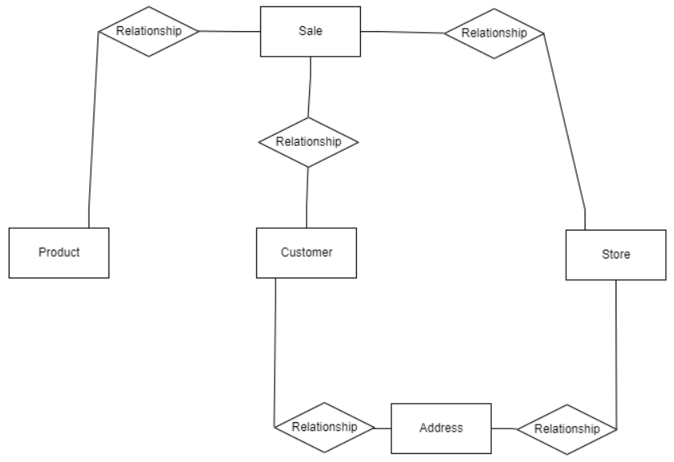
- Define the entities in the files that you think are candidates for being a HUB
Identify the HUBs and the Business_Keys that are defining them.
For example:
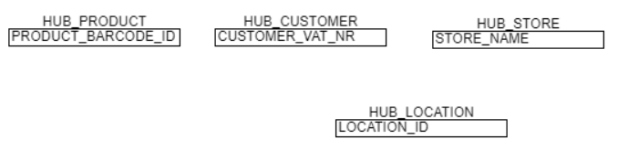
- For each HUB, define the SATELLITE you think are necessary
The attributes that you need for reporting go in the SATs.
For example:
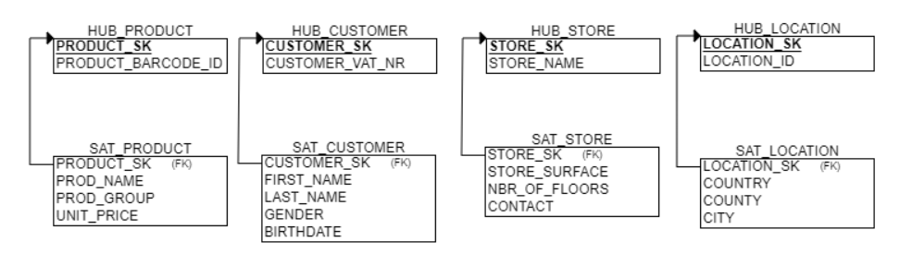

- Figure out what is linked together and how
Remember, LINKs can represent joins, but also events or transactions
For example:
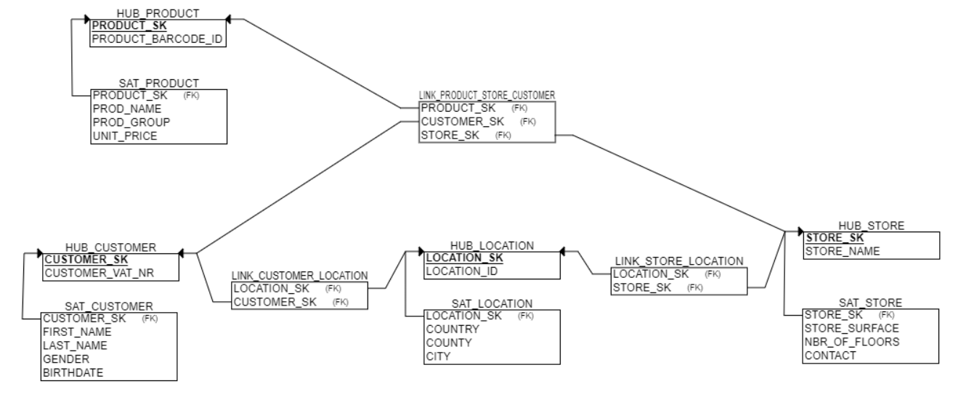
- What about the measures?
You need also your measures for the reporting.
Where are you storing them, and how to integrate the in the DV model?
For example:
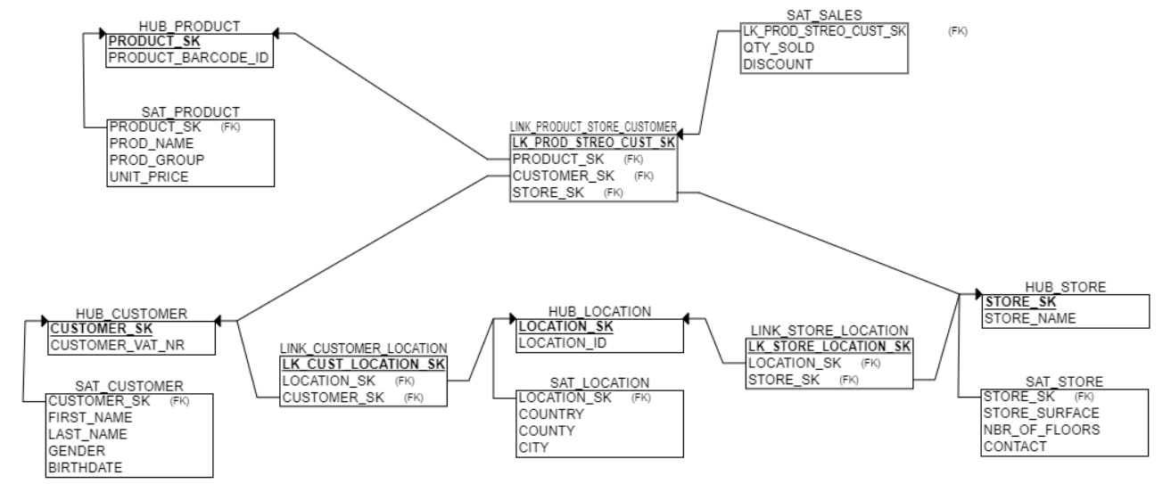
- Find the candidates for a Business Vault
Since we don't apply soft business rules to the Data Vault, find the calculations you would want to pre-calculate in the appropriate table(s)
They will be used in the reporting layer (datamart) , and by that way avoid a calculation in each datamart with the risk of different rules applied.
For example:
